

Semester Two Examination, 2016

Question/Answer Booklet

MATHEMATICS

SOLUTIONS
SPECIALIST
UNITS 3 AND 4

Section One:

Calculator-free

Student Number: In figures

In words

Your name

Time allowed for this section
Reading time before commencing work: five minutes
Working time for section: fifty minutes

Materials required/recommended for this section
To be provided by the supervisor
This Question/Answer Booklet
Formula Sheet

To be provided by the candidate
Standard items: pens (blue/black preferred), pencils (including coloured), sharpener, correction fluid/tape, eraser, ruler, highlighters

Special items: nil

Important note to candidates
No other items may be taken into the examination room. It is your responsibility to ensure that you do not have any unauthorised notes or other items of a non-personal nature in the examination room. If you have any unauthorised material with you, hand it to the supervisor before reading any further.

Structure of this paper

Section | Number of questions available | Number of questions to be answered | Working  time (minutes) | Marks available | Percentage of exam
Section One:  Calculator-free | 8 | 8 | 50 | 52 | 35
Section Two:  Calculator-assumed | 12 | 12 | 100 | 97 | 65
 |  |  | Total | 149 | 100

Instructions to candidates

1. The rules for the conduct of examinations are detailed in the school handbook. Sitting this examination implies that you agree to abide by these rules.

2. Write your answers in this Question/Answer Booklet.

3. You must be careful to confine your response to the specific question asked and to follow any instructions that are specified to a particular question.

4. Spare pages are included at the end of this booklet. They can be used for planning your responses and/or as additional space if required to continue an answer.
- Planning: If you use the spare pages for planning, indicate this clearly at the top of the page.
- Continuing an answer: If you need to use the space to continue an answer, indicate in the original answer space where the answer is continued, i.e. give the page number. Fill in the number of the question that you are continuing to answer at the top of the page.

5. Show all your working clearly. Your working should be in sufficient detail to allow your answers to be checked readily and for marks to be awarded for reasoning. Incorrect answers given without supporting reasoning cannot be allocated any marks. For any question or part question worth more than two marks, valid working or justification is required to receive full marks. If you repeat any question, ensure that you cancel the answer you do not wish to have marked.

6. It is recommended that you do not use pencil, except in diagrams.

7. The Formula Sheet is not to be handed in with your Question/Booklet.

Section One: Calculator-free 35% (52 Marks)
This section has eight (8) questions. Answer all questions. Write your answers in the spaces provided.

Working time for this section is 50 minutes.

Question 1 (5 marks)
The polynomial $h\left(z\right)=z^{4}-6z^{3}+3az^{2}-30z+10a$, where $a$ is a real constant, has a zero of $3-i$. Determine the value of $a$ and all other zeros of $h(z)$.

Solution
$h\left(z\right)=\left(z-3+i\right)\left(z-3-i\right)×f(z)$

$z^{4}-6z^{3}+3az^{2}-30z+10a=\left(z^{2}-6z+10\right)×f(z)$

By inspection, $f\left(z\right)=(z^{2}+bz+a)$

$z^{4}-6z^{3}+3az^{2}-30z+10a=\left(z^{2}-6z+10\right)(z^{2}+bz+a)$

Comparing $z^{3}$ coefficients, $-6=-6+b⇒b=0$

Comparing $z^{2}$ coefficients, $3a=10+a⇒a=5$

Hence $h\left(z\right)=(z^{2}-6z+10)(z^{2}+5)$

Other zeroes of $h\left(z\right)$ are $3+i, \sqrt{5}i$ and $-\sqrt{5}i$.

Specific behaviours
deduces another zero of $3+i$
uses two zeroes to obtain quadratic factor with real coefficients
deduces other factor must be of form $z^{2}+a$
determines value of $a$
lists required zeroes

Question 2 (8 marks)
Two functions are defined by $f\left(x\right)=\sqrt{3x-1}$ and $g\left(x\right)=\frac{1}{x}$.

(a) Determine the composite function $f(g\left(x\right))$ and the domain over which it is defined.
(3 marks)
Solution
$f\left(g\left(x\right)\right)=\sqrt{\frac{3}{x}-1}$

Domain: $\frac{1}{x}≥\frac{1}{3}⇒0<x≤3$.

Specific behaviours
writes composite function
states upper limit of domain as $x≤3$
states lower limit of domain as $x>0$

(b) Sketch the graph of $y=g(g\left(x\right))$ on the axes below. (2 marks)

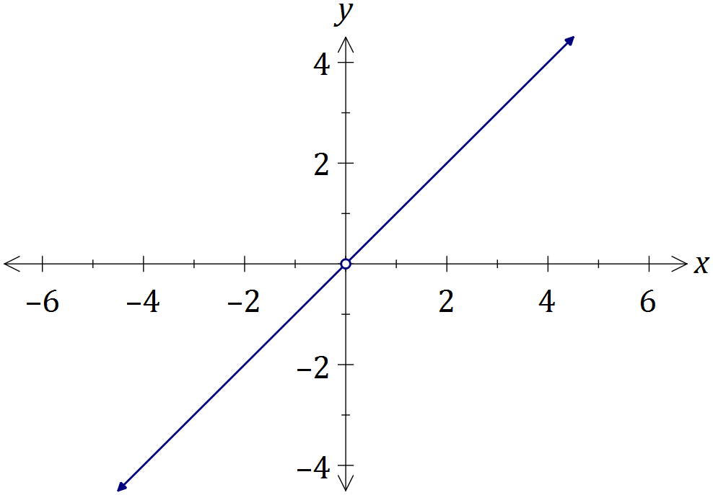
Solution
$g\left(g\left(x\right)\right)=x,x≠0$

Specific behaviours
sketches graph of $y=x$
indicates discontinuity at $x=0$

(c) The graph of $y=f(x)$ is shown below, passing through point $P$with coordinates $(2.62, 2.62)$. Determine $f^{-1}(x)$, the inverse of $f(x)$, and sketch the graph of $y=f^{-1}(x)$ on the same axes. (3 marks)

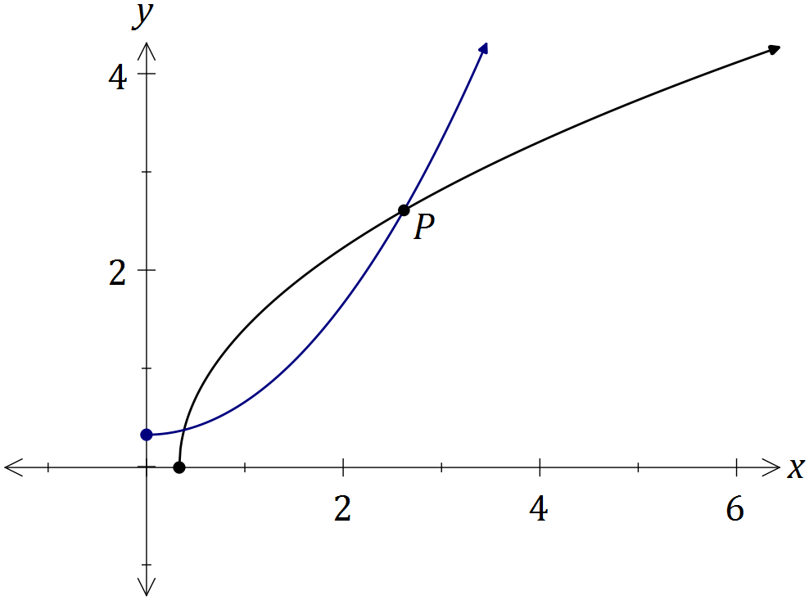
Solution
$x=\sqrt{3y-1}⇒y=f^{-1}(x)=\frac{x^{2}+1}{3}$

Specific behaviours
determines rule for inverse
sketches inverse using reflection in $y=x$
inverse starts at $\left(0,\frac{1}{3}\right)$ and passes thru $P$

Question 3 (5 marks)
An object, initially at rest, is dropped from the top of tall building so that after $t$ seconds it has velocity $v$ meters per second.

The air resistance encountered by the object is proportional to its velocity, so that the velocity satisfies the equation $\frac{dv}{dt}=10-kv$, where $k$ is a constant.

(a) Express the velocity of the object in terms of t and k. (4 marks)
Solution
$$\int{\frac{dv}{10-kv}}=\int{dt}$$
$$-\frac{1}{k}ln\left|10-kv\right|=t+c \\ ln\left|10-kv\right|=-kt-kc$$
$$10-kv=ae^{-kt} \\ t=0,v=0⇒a=10$$
$$v=\frac{10-10e^{-kt}}{k}$$

Specific behaviours
separates variables
integrates both sides
evaluates constant a
expresses velocity as required

(b) Sensors on the object indicate that its velocity will never exceed 55 metres per second. Determine the value of the constant k. (1 mark)
Solution
As $t→∞, 55=\frac{10}{k}⇒k=\frac{10}{55}=\frac{2}{11}$

Specific behaviours
evaluates constant

Question 4 (5 marks)
Let $v=\frac{\sqrt{2}}{2}-\frac{\sqrt{2}}{2}i$.

(a) Express $v$ in polar form. (2 marks)
Solution
$\left|v\right|=1,\arg{v}=-\frac{π}{4}, v=\operatorname{cis}\left(-\frac{π}{4}\right)$

Specific behaviours
determines correct modulus
determines correct argument

(b) Show that $v^{4}=-1$. (1 mark)
Solution
$$v^{4}={\left(\operatorname{cis}\left(-\frac{π}{4}\right)\right)}^{4}=\operatorname{cis}\left(-π\right)=-1$$

Specific behaviours
states $v^{4}$ in polar form

(c) Plot the roots of $z^{4}+1=0$ on the following Argand diagram. (2 marks)

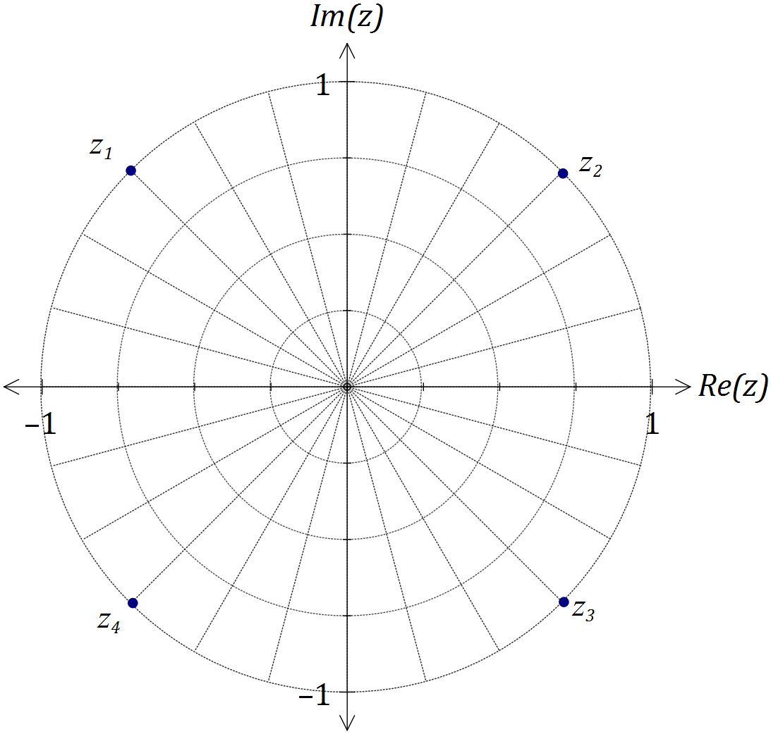
Solution
See diagram
Specific behaviours
adds scale and plots $v \left(=z_{1}\right)$
plots other three roots

Question 5 (8 marks)
(a) Using partial fractions, or otherwise, determine $\int{\frac{x-19}{(x+1)(x-4)}}dx$. (4 marks)
Solution
$A\left(x-4\right)+B\left(x+1\right)=x-19⇒A+B=1, B-4A=-19$

Solving gives $A=4, B=-3$

$$\int{\frac{x-19}{\left(x+1\right)\left(x-4\right)}}dx=\int{\frac{4}{x+1}-\frac{3}{x-4}}dx$$

$$=4\ln\left|x+1\right|-3\ln\left|x-4\right|+c$$

Specific behaviours
writes equations for A and B
determines A and B
integrates both fractions correctly
includes constant of integration

(b) Use the substitution $u=\sin{x}$ to evaluate $\int_{\frac{π}{6}}^{\frac{π}{2}}{\frac{cos⁡x}{\sqrt{\sin{x}}}}dx$. (4 marks)
Solution
$$du=\cos{x}dx, x=\frac{π}{2}⇒u=1, x=\frac{π}{6}⇒u=\frac{1}{2}$$

$$\int_{\frac{π}{6}}^{\frac{π}{2}}{\frac{cos⁡x}{\sqrt{\sin{x}}}}dx=\int_{\frac{1}{2}}^{1}{\frac{1}{\sqrt{u}}}du$$

$$={\left[2\sqrt{u}\right]}_{\frac{1}{2}}^{1}$$

$$=2-\sqrt{2}$$

Specific behaviours
uses substitution correctly
determines new bounds of integration
integrates correctly
evaluates integral

Question 6 (5 marks)
The differential equation $y^{'}=\frac{2x}{y}$ is shown in just one of the four slope fields below.

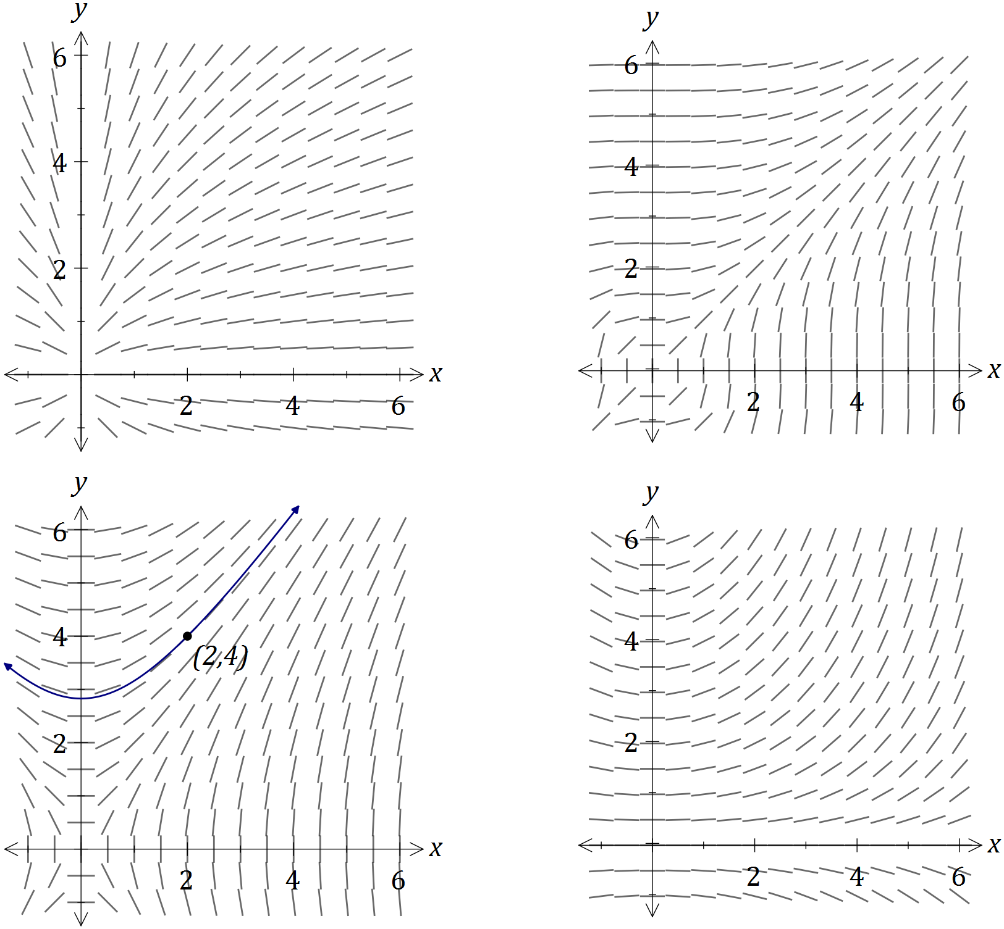
Solution
See bottom left-hand slope field
Specific behaviours
chooses correct slope field
uses slopes to sketch solution curve right of pt.
uses slopes to sketch solution curve left of pt.

(a) On the slope field for $y^{'}=\frac{2x}{y}$, sketch the solution of the differential equation that passes through the point $(2, 4)$. (3 marks)

(b) Another solution to the differential equation passes through the point $\left(6, -3\right).$ Use the incremental formula $δy≈\frac{dy}{dx}×δx$, with $δx=\frac{1}{10}$, to estimate the y-coordinate of this curve when $x=6.1$. (2 marks)
Solution
$$δy≈\frac{2\left(6\right)}{-3}×\frac{1}{10}=-0.4 \\ y≈-3-0.4≈-3.4$$

Specific behaviours
calculates change in y
calculates new y-coordinate

Question 7 (8 marks)
The function $f$ is defined as $f\left(x\right)=\frac{x^{2}-1}{x^{2}+1}$.

(a) Show that the only stationary point of the function occurs when $x=0$. (2 marks)
Solution
$$f^{'}\left(x\right)=\frac{2x\left(x^{2}+1\right)-2x\left(x^{2}-1\right)}{{\left(x^{2}+1\right)}^{2}}=\frac{4x}{{\left(x^{2}+1\right)}^{2}}$$

Hence $f^{'}\left(x\right)=0$ only when $4x=0⇒x=0$.

Specific behaviours
differentiates function
simplifies and makes conclusion

(b) Sketch the graph of $y=f(x)$ on the axes below. (3 marks)

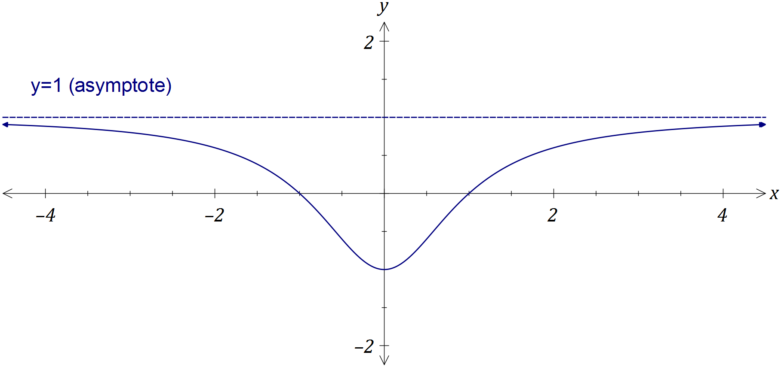
Solution
See graph
Specific behaviours
turning point
roots
approaches asymptote from below

(c) Using your graph, or otherwise, determine all solutions to

(i) $f\left(x\right)=\left|f(x)\right|$. (1 mark)
Solution
$x≤-1 ∪ x≥1$

Specific behaviours
states both inequalities

(ii) $f\left(x\right)=f(\left|x\right|)$. (1 mark)
Solution
$x∈R$

Specific behaviours
states all reals

(iii) $f\left(x\right)=\frac{1}{f\left(x\right)}$. (1 mark)
Solution
$x=0$

Specific behaviours
states solution

Question 8 (8 marks)
A region is bounded by $x=0, y=0$ and $y=\ln{(x+3)}$ as shown in the graph below.

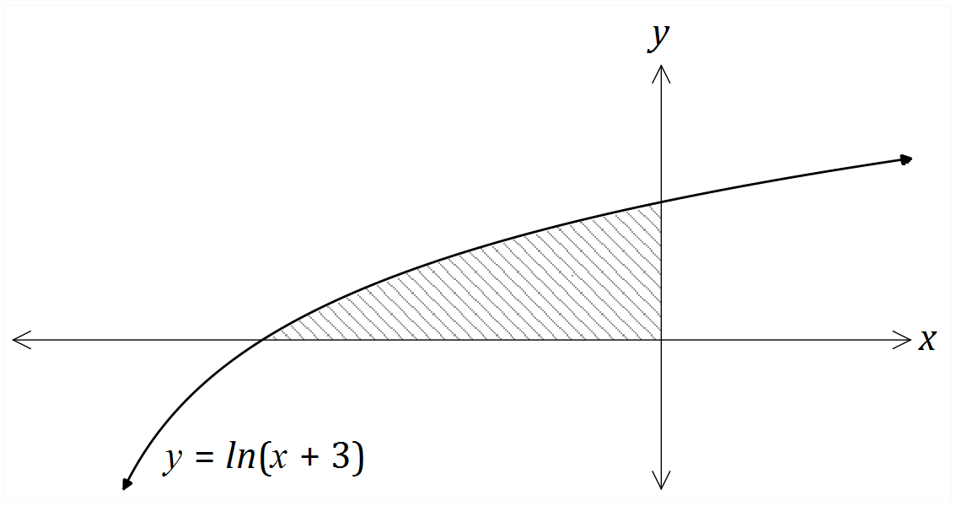

(a) Show that the area of the region is given by $\int_{0}^{\ln{3}}{({3-e}^{y})}dy$. (3 marks)
(Do not evaluate the integral).
Solution
$$y=\ln\left(x+3\right)⇒x=e^{y}-3, x=0⇒y=\ln{3}$$

Region is left of y-axis, so integral will be negative - need to multiply by -1 for area

$$A=-\int_{0}^{\ln{3}}{\left(e^{y}-3\right)}dy=\int_{0}^{\ln{3}}{({3-e}^{y})}dy$$

Specific behaviours
expresses x in terms of y
derives upper limit of integration
explains need to multiply integral by -1,

(b) Determine the volume of the solid generated when the region is rotated through $2π$ about the y-axis. (5 marks)
Solution
$$V=π\int_{0}^{\ln{3}}{{\left(e^{y}-3\right)}^{2}}dy \\ =π\int_{0}^{\ln{3}}{e^{2y}-6e^{y}+9}dy \\ =π{\left[\frac{e^{2y}}{2}-6e^{y}+9y\right]}_{0}^{\ln{3}} \\ =π\left[\frac{9}{2}-18+9\ln{3}-\frac{1}{2}+6\right] \\ =π(9\ln{3}-8)$$

Specific behaviours
writes correct integral
expands ${\left(e^{y}-3\right)}^{2}$
integrates correctly
substitutes upper and lower limits
simplifies completely

Additional working space

Question number: _________

© 2016 WA Exam Papers. Churchlands Senior High School has a non-exclusive licence to copy and communicate this paper for non-commercial, educational use within the school. No other copying, communication or use is permitted without the express written permission of WA Exam Papers.

